**CHAPTER 2**

**ARCHITECTURE OF LIBRARY MANAGEMENT SYSTEM**

**2.1 BLOCK DIAGRAM**

Figure 2.1 (a) gives the overview of the flow and hence the functionalities available for a Member of Library Management System. Once the Member has loggin successfully into LMS,

* He can view his account details.
* He can search for the availability of the book by entering Book ID or author name and then he may request for an issue of the same.
* He may wish to return the book which he had borrowed earlier and pay the fine for the book if he had not returned the book within the due time.

Figure 2.1 (b) gives the overview of the flow and hence the functionalities available for a Librarian and Library Administrator of Library Management System. Once the librarian has loggin successfully into LMS,

* He can search for the book based on the request of a member.
* He can add or delete or update the details of an book as and when needed
* He can issue or return a book based on the request of a member which involves validating membership of the member.
* He may wish to manage dues of a member based on the request.

Library Administrator can perform all the actions performed by the librarian. Additionally,

* He can add or update or disable a member account when needed.
* Place the order for the book based on the member demand.
* He can also generate report of transactions.

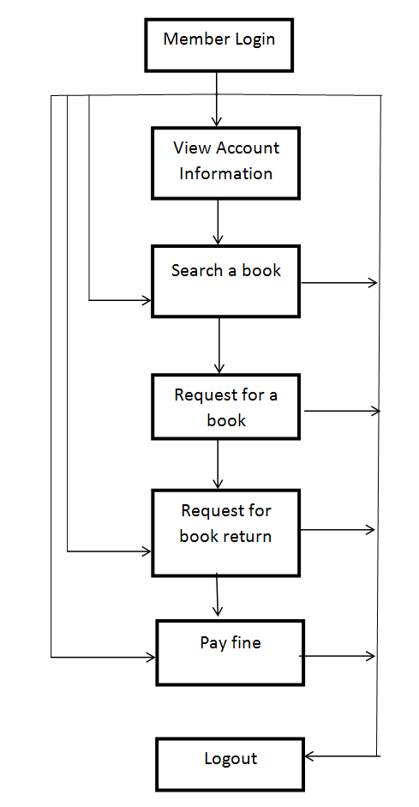

**Figure 2.1 (a) LMS Block Diagram**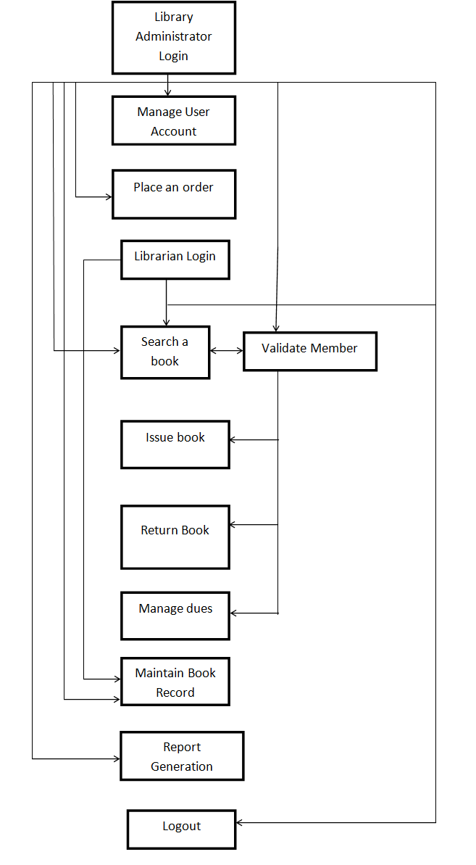

Figure 2.1 (b) LMS Block Diagram